Twelfth Avenue Elementary – School Plan
Who we are? (With considerations for ELL, Inclusive Ed, CYOC, Indigenous students)

Our school community is made up of just over 300 students and a dedicated team of staff, including 23 classroom teachers, 3 part-time specialist teachers, and 2 part-time Settlement Workers in Schools (supporting Farsi, Pashto/Dari, tigrinyaand Arabic-speaking families). We also have 10 Education Assistants, a Food Service Worker, 2 custodians, 2 Lunch Hour Supervisors, a Crossing Guard, a Strong Start Educator, a Secretary, an Office Support Worker, a Head Teacher and an Administrator. Every member of our team shares a deep appreciation for this community, describing it as a place of care and collaboration.

We are a Kindergarten to Grade 7 school with 13 classrooms. Over half of our students, 165 in total, receive English Language Learning (ELL) support, as they come from bilingual or multilingual households. The most commonly spoken home languages include Tagalog, Pashto/Dari, Mandarin, Spanish, and Arabic. Our school is a vibrant and diverse community, enriched by many cultures. We have 5 students of Indigenous descent from Nations across British Columbia, and we currently support 23 students with diverse needs and abilities.

A key focus of our school is meeting the needs of our broader community. We operate a Breakfast Program five days a week, serving 20 to 25 regular participants. Student volunteers from Saint Thomas More Collegiate (STMC) assist with preparing breakfast and engaging with our students. A fruit bowl at the office is replenished twice daily for anyone in need of a snack. We are grateful to the Burnaby Firefighters for their donations of snacks and cereals, which support both our classrooms and Breakfast Program. Additionally, we participate in the District Hot Lunch Program, with The Lunch Lady catering service providing daily hot meals to an average of 110 students each month.

Other programs include the Cameray ACTS program, which is now in its third year. It offers an after-school dinner and homework club for Grade 6 and primarily Grade 7 students. This program helps ease the transition to high school. Students greatly enjoy this time together. Also, our SWIS worker sponsors the Friends of Simon after-school mentorship program. Four university students provide tutoring and games for a group of 18 refugee students every Friday throughout the school year. The program culminates in a celebratory field trip to Simon Fraser University each April.

Our Story

What are we doing well?
Knowing our students is a strength at Twelfth Avenue. We have focussed on early targeted literacy interventions, and one of our LSS teachers did Reading Recovery in past years with selected Grade 1 students. In January, our Speech Language Pathologist does Kindergarten assessments based on teacher feedback, and our Kindergarten and ELL/LSS teams assess our Kindergarteners progress in literacy (letter recognition and phonics). Based on these assessments, our ELL/LSS team begins some targeted Tier 2 interventions with our Kindergarteners.
All of our classrooms do standardized reading assessments twice a year (EPRA & DART) and students’ results are recorded yearly. Our School Based Team (LSS, ELL, Counsellor, Head Teacher, SLP [when requested] and Principal) use this data to plan our Tier 2 & 3 interventions. Currently we have a whole school literacy block (1:00-1:45) and at this time students whose proﬁles have been assessed by our school psychologist to beneﬁt from Lexia reading intervention go to the Computer Lab for their individualized reading program. Our LSS teacher supports this block of time ensuring students are setting and completing daily literacy goals.
Our school does Class Reviews twice a year (early October and in February). We use Shelley Moore’s Class Proﬁle graphic organizer to prompt our discussions. In February, often the classrooms may have new learners, and the teacher has time to share their progress on the goals they selected for their class at the beginning of the year or ways they have had to shift practice. Our support team also has an opportunity to review the vulnerability data and assess the current services.
Our ELL teachers and K/1 and 1/2 classrooms have started a home reading program as access to reading materials at their level (given that some members may not read English) may not be available. Our ELL team is also ﬂexible in the type of servicing they provide for classrooms (pull-out small groups or in-class team or SIOP [Sheltered Instruction Observation Protocol] teaching). Our Music teacher has 0.1 ELL and with this time she supports our non-speaking students with diverse needs in their English language acquisition through rhyming songs with actions to meet them at their developmental level.

How do we know?
For the past three years, our school has focused on a mathematical literacy goal. The ﬁrst two years was focusing on building resources for staﬀ to use in mathematics and developing their ability to try diﬀerent models of instruction in mathematics; open ended questions and or highlighting the many ways students can solve a similar problem.
This last year, we decided to target problem solving and students’ communicating how they solved a problem and agreed on implementing math journals school-wide. Staﬀ met in similar grade groups, discussed genres of mathematical literacy that would apply their student’s developmental level, and then decided on a common rubric they would use to assess students’ entries. This occurred three times this school year: Nov/Dec, Feb, and May. We used these journals and rubrics to assess students’ development in mathematical literacy. Teachers shared an assessment of the Nov/Dec data and compared it with their May assessments of students in Numeracy overall.
We then looked at the June Numeracy Report Card Data and FSA Numeracy Data which is on the following page.

FSA Data for 2024-2025

Grade 4 2024/25 60% On Track or Extending for Grade 4’s
Numeracy
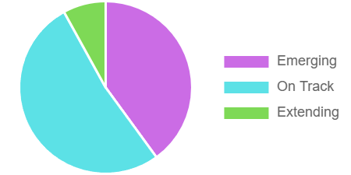
 | Participation Rate – Writers Only
 | # | %
Emerging | 10 | 40.00
On Track | 13 | 52.00
Extending | 2 | 8.00

Grade 7 2024/25 70% On Track or Extending for Grade 7’s

Numeracy
 | Participation Rate – Writers Only
 | # | %
Emerging | 7 | 29.17
On Track | 14 | 58.33
Extending | 3 | 12.50

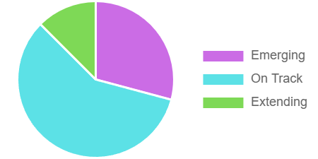
Numeracy Report Card Data for 2024-2025
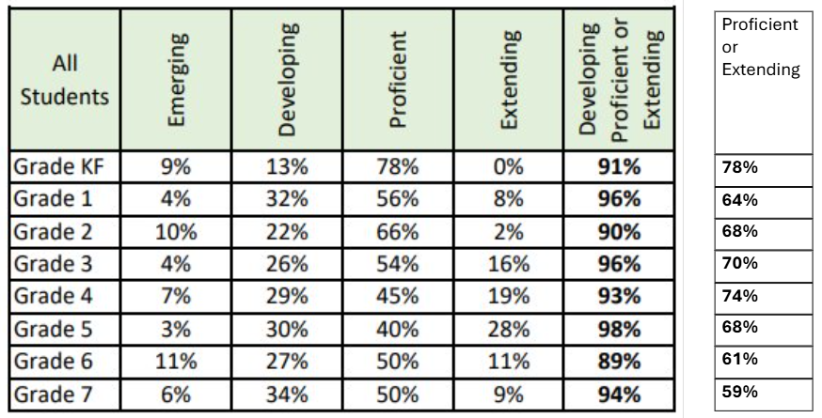

Our focus:
Based on the data, our focus for the 2025-2026 year is to continue working on developing Numeracy Skills for our students.
Goal:
Improving Mathematical Literacy of Students
- To increase the number of students who are proficient or extending in Numeracy
- To focus on students showing their learning in multiple ways: words, pictures and orally
Kindergarten to Grade 7 classrooms will assess mathematical literacy orally, visually or in writing in a Math Journal. The focus will be on students communicating their mathematical understanding of the language of problem solving. Our focus will be on teachers explicitly teaching the language of problem solving, recognizing key words and creating word problems. Teachers will assess all students using an agreed upon rubric in the fall and the spring, specifically tracking ELL students and their growth.

STRATEGIES: (to support Focus)

- Frequent opportunities for staff to bring their students’ journals to staff meetings and or professional development days to assess and/or discuss progress
- Invite the ELL Helping Teacher to share strategies for teaching math vocabulary to ELL students
- Sharing resources with staff to facilitate the instruction in their classrooms
- Having common, agreed upon dates to have formative assessments completed throughout the year

